00.06
Data and reports
Process Design & AMOS Configuration Document
Purpose
This Process Design document is provided to Key-Users to record their key decisions regarding the AMOS Process design and the required AMOS configuration.
It is updated throughout the Project Definition Phase and used as the baseline for the Final Acceptance prior to Go-Live
Revision
Author, Name | Date | Notes
ADKE Adam Kelemen | 14.05.2024 | First version

Table of Contents
1. Process Overview & Objectives 2
2. Regulatory References 3
3. Definitions & Glossary 3
4. Process Tasks 3
5. Process Dependencies 4
6. Process Flow 4
7. Process Design Questions 6
8. Data (Source) Mapping 6
9. Other Software Used 7
10. AMOS Configuration 7
a. Basic Data 8
b. Parameters 8
c. Workflows 8
d. Scheduled Tasks 8
e. API’s & Interfaces 8
11. Annex – Additional Info 8

Process Overview & Objectives

Process General Description:
This process will help the AMOS Competence Center (ACC) team to streamline the handling of data related issues or errors. Also shows how to handle new report request from the business users.
This process separates 2 main flows:
- If there is a data quality issue or faulty data
- If there is a request for reporting certain data
In case there is data quality issue, or faulty data, there are tools available in AMOS that can identify the issues. The process mentions these so that the ACC can help to identify and possibly fix the errors. Sometimes the data is too complex to fix, in that case ACC must reach out to Swiss-AS in a support case.
The process also covers if users need new ways of reporting data. ACC must assess first if business users maybe overlooked some existing report options, then check if they can deliver an easy solution.
This process will show that ACC can use Report Designer (APN 966) to develop a completely new report.
Main Process Objective (Outputs & Outcomes):
The main stakeholders of the Data and Reports are:
- Business users: they identify data issues. Or define new reporting request.
- ACC: they perform investigation and solutions for data errors or new reports.
Another outcome can also be a business process modification, to avoid future issues.

Regulatory References

N/A

Definitions & Glossary

Key-Words | Explanation
ACC | This acronym relates to the AMOS Competence Centre
Business Users | The people who work in AMOS.
Report Designer | A tool in AMOS that can change existing reports or produce new reports with graphical editor and the help of SQL queries. AMOS database knowledge is strongly recommended.

Process Tasks

Business Process Task / Actions / Activities:
- New requests come to ACC from business users through Technical Assistance (APN 869).
- ACC classifies if it’s a data error, or new report.
- If its data issue: ACC goes through a process of identifying the issues. Must check related Data Verification (APN 1427) jobs, scheduler task logs (APN 2606), must check AMOS logs (APN 9). Usually, the errors are identified here. If not, ACC must ask Swiss-AS for help.
- Once data issue root cause is identified, ACC must develop a plan to provide the solution. Can be manual data correction. It also can be SQL data correction. In this case, please crosscheck with Swiss-AS.
Additionally, the solution can be modification in the business processes to avoid the data issues in the future.
- In case a new report is needed from the business users: ACC must first assess if you really need to develop a new report, or there are existing available options which the business user might have missed or does not have the access right to it.
- It can happen that the report is to complex for the ACC team. Please remember, there is always the option to utilize alternative reporting tools, that could be plugged in to the AMOS database. (Power BI, Sisense etc...)
- If a new report is really needed and can be done in AMOS, ACC must gather requirements and develop the report.
- ACC must also deploy the report. Either it’s a change in an existing report, or it needs to be positioned in the upper AMOS application menu structure.

Process Dependencies

- 00.03 – Technical Assistance process.
- Proper logging of AMOS must be configured to help troubleshooting processes.
- For report Designer usage, strong AMOS DB knowledge is advised.
- 00.01 – Application Configuration process for deployment of reports.

Process Flow

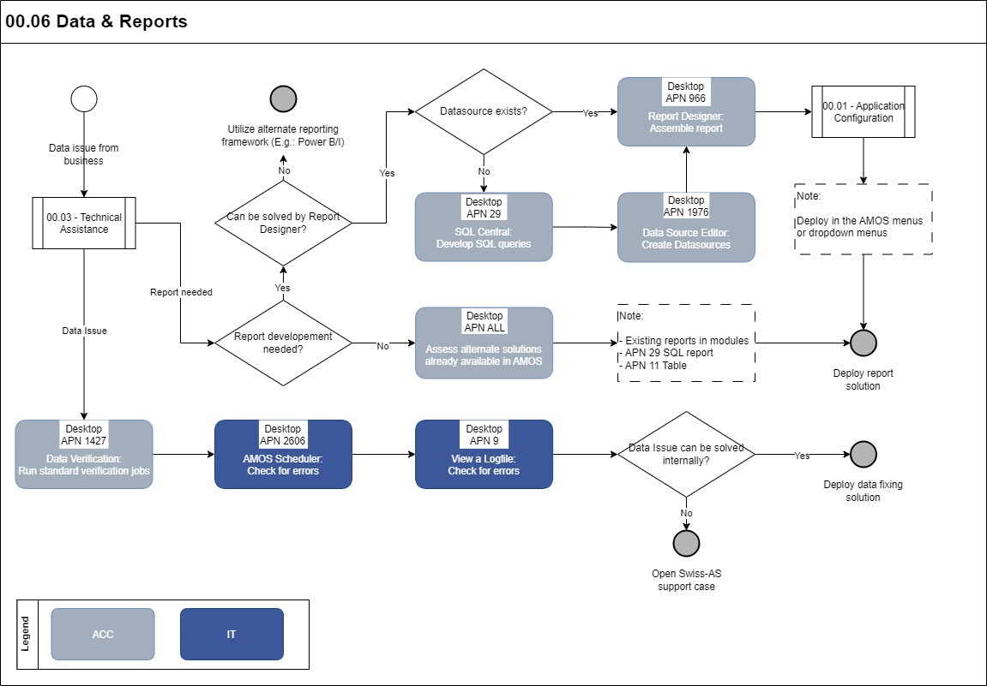

Process Design Questions

# | Question | Answer
1 | Can IT responsibilities be replaced by ACC on this process? | Yes, it’s up to the Customer to decide.
2
3
4
5
6

Data (Source) Mapping

Data Sources | Description | Volume / Manual / Automatic / Static / Dynamic
Technical Queries | Business users create these | Dynamic data
Other reports | In report designer, you can look for other report solutions | Static
SQL queries | Defining new reports, you can create your own data sources | Dynamic

Other Software Used
Optional:
Other Softwares | Used by: | Description
Power BI | ACC | External Data Visualization Software
Sisense | ACC | External Data Visualization Software

AMOS Configuration

Basic Data

Basic Data Table | Notes
-

Parameters

Parameter Code | Parameter Name | Notes
1380 | COPYRIGHT-STATEMENT FOR REPORTS
1407 | REPORT MARGIN ADJUSTMENT

Workflows

Workflow Number | Workflow Name | Notes
-

Scheduled Tasks

Scheduled Task Reference | Frequency | Notes
AmosDataVerificationTask | Up to Customer | Can run selected Data Verification tasks regularly
GenerateReportServerTask | Up to Customer | Creates a PDF report, exports it to a folder and sends it via email.

API’s & Interfaces

Reference | Direction | Trigger | Frequency

Annex – Additional Info

